# Course: web technnology

TOPIC:

BIBA AFRICA SYSTEM

**ID:25756**

**NAMES: UWAYEZU Bienvenu**

# Deployed Link for project: https://uwayezubienvenu.herokuapp.com/

To login as administrator your email must be belongs this word “**biba123**”

Contents

Course: web technnology 1

BIBA AFRICA 3

1.1 Introduction 3

1.2 Ambition 3

1.3 Scope of the system 3

1.4 Entity relationship of the system 4

1.5 Design orgaisation of the system 5

# BIBA AFRICA

## 1.1 Introduction

Biba Africa is an advanced platform designed to assist psychologists in delivering high-quality mental health services. With its intuitive interface and powerful features, Biba Africa simplifies the therapeutic process and facilitates effective communication between psychologists and clients.

Psychologists can create detailed profiles showcasing their qualifications and therapeutic approaches, allowing clients to choose the most suitable professional for their needs. The platform ensures secure appointment scheduling, confidential messaging. Additionally, psychologists can access a vast resource library, administer assessments, track client progress.

## 1.2 Ambition

Biba Africa promotes professional networking and collaboration, enabling psychologists to connect with peers and engage in knowledge sharing. Overall, Biba Africa is dedicated to enhancing mental well-being and empowering individuals to lead fulfilling lives

Analytics and Reporting: Biba Africa offers robust analytics and reporting functionalities, allowing psychologists to track client progress, monitor outcomes, and identify trends. This data-driven approach empowers psychologists to make informed decisions and adjust treatment plans as needed.

Professional Networking and Collaboration: Psychologists can connect with their peers, join professional communities, and engage in collaborative discussions through the networking feature. This promotes knowledge sharing, peer support, and professional growth within the Biba Africa community.

## 1.3 Scope of the system

1. Helps people find and communicate with psychologists they want to work with
2. Gives psychologists tools and resources to provide therapy and track their clients' progress
3. Provides a library of self-help materials and other resources for clients and psychologists to use
4. Connects psychologists with each other to share knowledge and support each other
5. Provides data analytics and reporting to help psychologists understand how well their therapy is working

## 

## 1.4 Entity relationship of the system

client

Signup

Contact us

Singup

Suggestion

On the system

1,n 1,nn

1,n

1,n

## 1.5 Design orgaisation of the system

Welcome page

login

signup

Admin page

Client page

home

request

comment

Psychologist description

logout

home

View case

search

Download report

message

Create account

logout

**Here are images of shows the structure of my project**

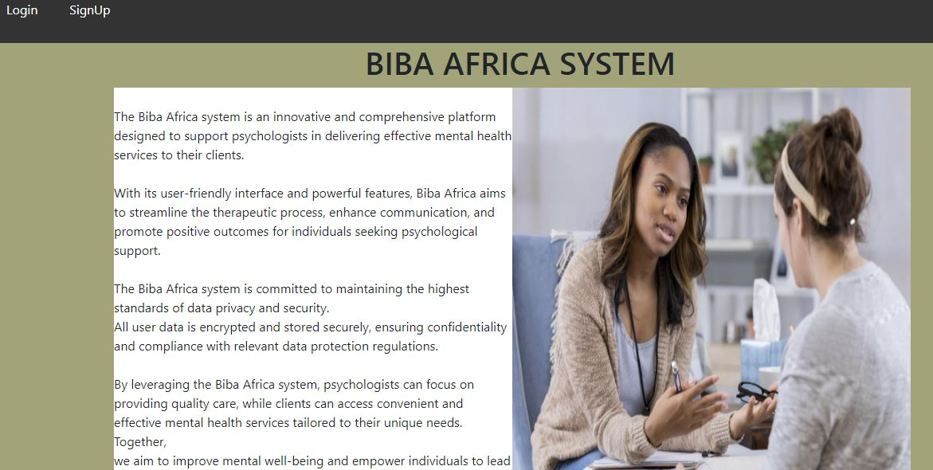

**Welcome page**



**Page for search**

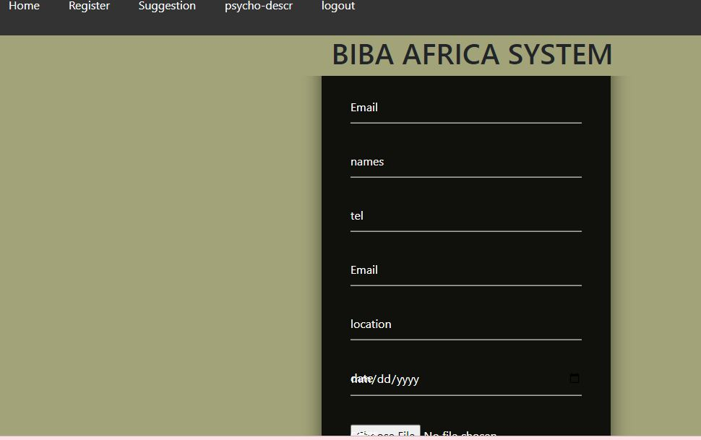

**for registration**

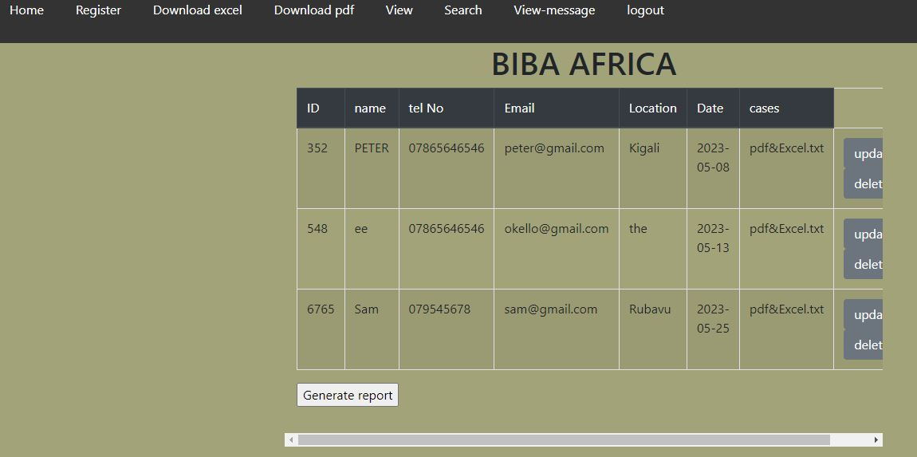

**For view**